### COVID VACCIENS ANALYSIS

**TEAM MEMBER**

**412621243020: GOKUL P**

# Phase-1 Document Submission

**Project: Covid Vaccines Analysis**

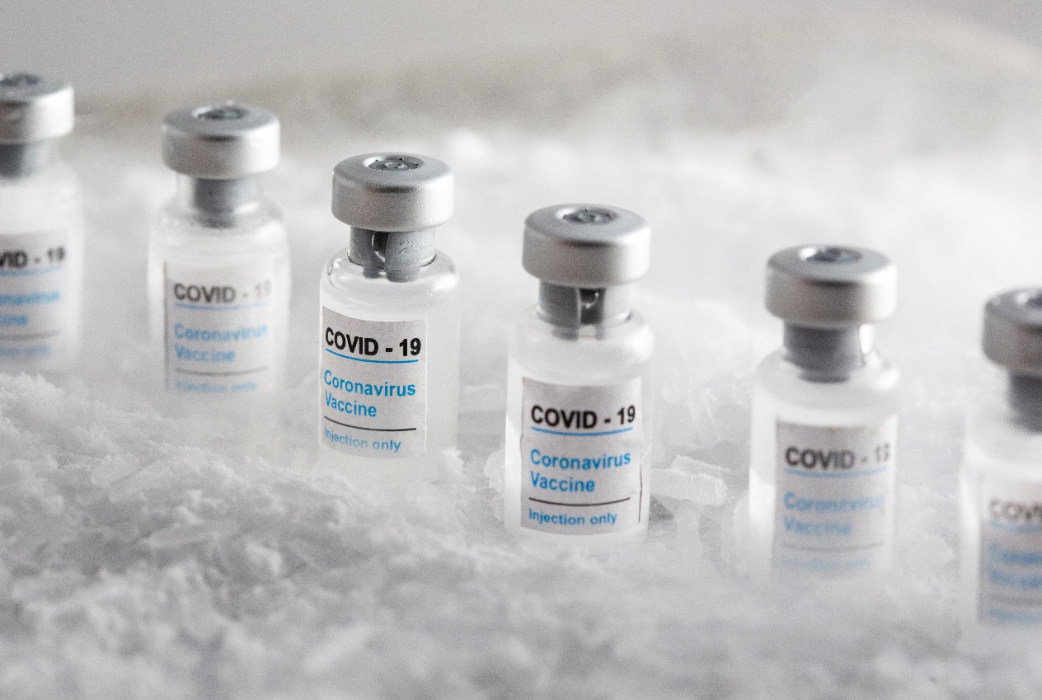

### OBJECTIVE:

The objective of COVID-19 vaccine analysis is to assess the safety, efficacy, and overall performance of COVID-19 vaccines in preventing COVID-19 infections, reducing the severity of the disease, and minimizing its impact on public health. This analysis involves rigorous testing, clinical trials, and ongoing monitoring to ensure that vaccines are effective and safe for widespread use. Additionally, vaccine analysis aims to identify any potential adverse effects and to provide data to guide vaccination strategies and public health policies.

**Phase 1: *Data Preprocessing and Feature Engineering***

# Data Source

The primary data sources for COVID-19 vaccine analysis include:

1. Clinical Trials: Data from controlled studies conducted during vaccine development, which assess vaccine safety and efficacy in human participants.

2. Surveillance Systems: Monitoring of adverse events and vaccine coverage data through systems like the Vaccine Adverse Event Reporting System (VAERS) and the Vaccine Safety Datalink (VSD).

3. Healthcare Records: Analysis of medical records, electronic health records, and hospital data to track vaccine effectiveness and safety in real-world settings.

4. Epidemiological Studies: Large-scale studies conducted to evaluate vaccine performance at a population level, tracking infection rates, hospitalizations, and outcomes.

5. National Health Agencies: Data collected and analyzed by government health agencies, such as the Centers for Disease Control and Prevention (CDC) and the World Health Organization (WHO).

6. Vaccine Manufacturers: Data provided by vaccine manufacturers on clinical trials, manufacturing processes, and quality control.

These sources collectively contribute to the ongoing assessment of COVID-19 vaccines and help inform vaccination strategies and public health decisions.

Project Dataset Link:

**[https://www.kaggle.com/datasets/gpreda/covid-world-vaccination-progress](https://www.kaggle.com/datasets/gpreda/covid-world-vaccination-progress" \t "[object Object])**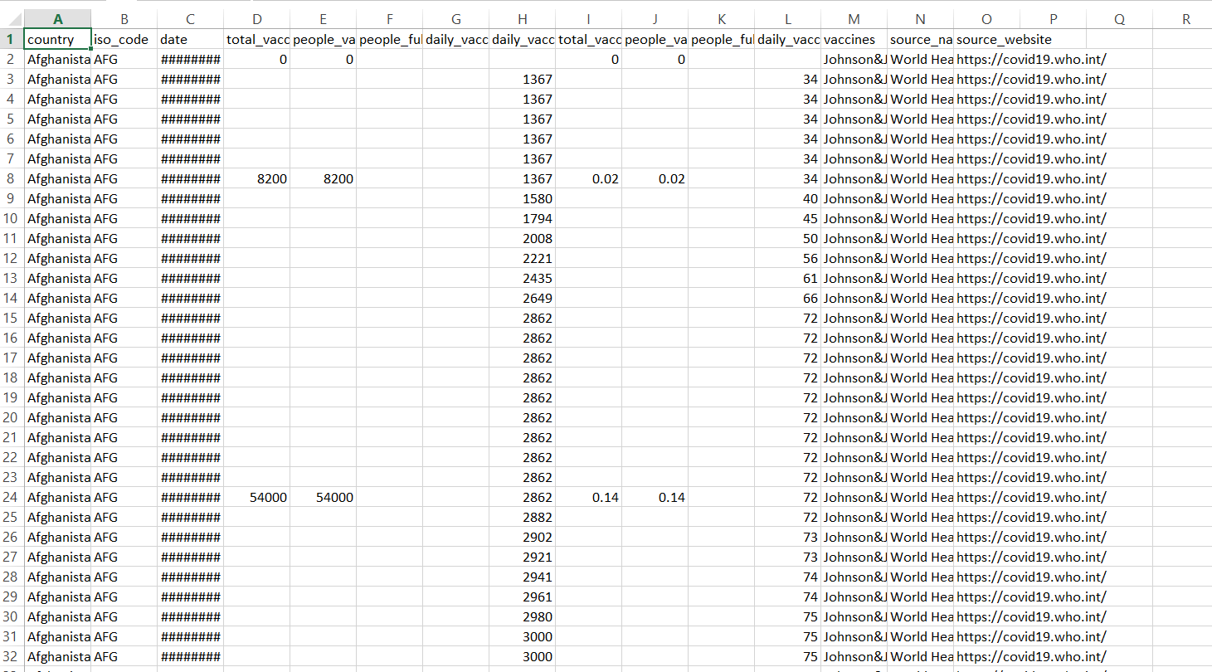

# Data Preprocessing

Data preprocessing in COVID vaccine analysis involves preparing and cleaning the raw data collected from various sources to make it suitable for analysis.This process typically includes:

Data Cleaning: Identifying and handling missing values, outliers, and errors in the data to ensure data quality.

Data Integration: Combining data from different sources or datasets into a unified format for analysis.

Data Transformation: Converting data into a consistent format, such as standardizing units of measurement or encoding categorical variables numerically.

## Duplicate Removal:

Duplicate removal in COVID vaccine analysis refers to the process of identifying and eliminating duplicate or redundant data entries within a dataset related to COVID-19 vaccines. This step is crucial to ensure data accuracy and prevent bias in analysis results. Duplicate removal typically involves identifying records with identical or highly similar information and retaining only one instance of each unique data point, reducing the risk of skewing analytical outcomes due to repetitive or erroneous data..

## Handling Missing Values:

Handling missing values in COVID vaccine analysis involves several approaches:

Data Imputation: Replace missing values with estimated or imputed values. Common methods include mean, median, mode imputation, or more advanced techniques like regression imputation.

Deletion: Remove rows or columns with missing values. This can be appropriate if missing.

Interpolation: Use methods like linear interpolation for time-series data to estimate missing data is limited and doesn't significantly affect the analysis values based on surrounding data points.

Predictive Modeling: Build predictive models to predict missing values based on other variables in the dataset.

Flagging: Create a flag variable to indicate missing values in the dataset. This allows you to distinguish between observed and missing data during analysis.

Multiple Imputation: Generate multiple imputed datasets, perform analysis on each, and then combine results. This accounts for uncertainty due to missing data.

Domain-Specific Imputation: In some cases, domain knowledge can guide the imputation process. For example, missing vaccine doses could be imputed based on the recommended vaccination schedule.

The choice of method depends on the nature of the data and the goals of the analysis. Handling missing values appropriately is crucial to ensure the integrity and reliability of COVID vaccine analysis results.

## Categorical Variable Encoding:

In COVID vaccine analysis, categorical variable encoding is the process of converting categorical data, such as vaccine types or patient demographics, into a numerical format that machine learning algorithms can use for analysis. Common encoding techniques include:

Label Encoding: Assigning a unique integer to each category. For example, if you have vaccine types like "Pfizer," " Moderna ," and "Johnson & Johnson," you might encode them as 0, 1, and 2.

One-Hot Encoding: Creating binary columns for each category, where each column represents the presence or absence of a category. This method is useful when categories have no inherent order or ranking.

## Data Normalization:

Data normalization in COVID vaccine analysis is the process of scaling and standardizing data to a common range or distribution. This is done to ensure that different features or variables used in the analysis are on a consistent scale, which can help improve the performance of machine learning models, statistical analyses, and other data-driven techniques.

### PYTHON PROGRAM:

import pandas as pd

import numpy as np

import matplotlib.pyplot as plt

import seaborn as sns

import plotly

import plotly.express as px

import plotly.graph_objects as go

import folium

from folium import plugins

plt.rcParams['figure.figsize'] = 10, 12

import warnings

from sklearn.metrics import mean_squared_error

warnings.filterwarnings('ignore')

%matplotlib inline

df_India= pd.read_csv('covid_19_India.csv')

India_coord = pd.read_excel('Indian Coordinates.xlsx')

print(df_India.info())

df_India.head()

df_India.tail()

df_India.dtypes

print(India_coord.info())

India_coord.head()

def replace_dash_with_zeros(inp):

return int(inp.replace("-","0"))

df_India.drop(['Sno'],axis=1,inplace=True)

df_India['Date'] = pd.to_datetime(df_India['Date'], format = "%d/%m/%y")

# https://www.stat.berkeley.edu/~s133/dates.html

df_India['ConfirmedIndianNational'] = df_India['ConfirmedIndianNational'].apply(replace_dash_with_zeros)

df_India['ConfirmedForeignNational'] = df_India['ConfirmedForeignNational'].apply(replace_dash_with_zeros)

df_India.sort_values("Confirmed", ascending = False, inplace = True)

df_India

df_India.loc[df_India["ConfirmedForeignNational"] == "-",:]

list(zip(df_India.columns,df_India.dtypes,df_India.isna().sum()))

print(f'We have data available from : {df_India.Date.min()} to {df_India.Date.max()}')

df_India.groupby(["State/UnionTerritory", "Date"]).sum()

States = df_India['State/UnionTerritory'].unique().tolist()

States

States.remove("Cases being reassigned to states")

States.remove("Unassigned")

States

len(States)

df_final_India = pd.DataFrame()

dates = pd.DataFrame({"Date": pd.date_range(df_India.Date.min(),df_India.Date.max())})

for state in States:

all_dates_df = pd.merge(dates,

df_India.loc[df_India['State/UnionTerritory'] == state,:], on = "Date",

how = "left")

all_dates_df['State/UnionTerritory'] = state

all_dates_df = all_dates_df.fillna(0)

all_dates_df['New Cases'] = all_dates_df['Confirmed'] - all_dates_df['Confirmed'].shift(1)

# print(state)

# display(all_dates_df.loc[all_dates_df['New Cases'] < 0,:])

df_final_India = pd.concat([df_final_India, all_dates_df],axis = 0)

print("Finally we have a data of Size: ",df_final_India.shape)

df_final_India.head()

df_final_India.dropna(inplace = True)

df_final_India.shape

del df_final_India['Time']

del df_final_India['ConfirmedIndianNational']

del df_final_India['ConfirmedForeignNational']

df_final_India

df_final_India.groupby(["State/UnionTerritory", "Date"]).sum()

df_final_India = df_final_India.groupby(["State/UnionTerritory", "Date"]).sum().reset_index()

df_final_India

def plot_pie(active,cured,death,title):

labels = ['Active','Recovered','Died']

sizes = [active,cured,death]

color= ['#66b3ff','green','red']

explode = []

for i in labels:

explode.append(0.05)

plt.figure(figsize= (15,6))

plt.pie(sizes, labels=labels, autopct='%1.1f%%', startangle=9, explode =explode,colors = color)

centre_circle = plt.Circle((0,0),0.70,fc='white')

fig = plt.gcf()

fig.gca().add_artist(centre_circle)

plt.title(title + 'COVID-19 Cases',fontsize = 20)

plt.axis('equal')

plt.tight_layout()

total_cases_india = 0

cured_cases_india = 0

death_cases_india = 0

active_cases_india = 0

state_df = pd.DataFrame()

for state in States:

one_state_df = df_final_India.loc[df_final_India['State/UnionTerritory'] == state,:]

state_df = pd.concat([state_df,pd.DataFrame(one_state_df.iloc[-1,:]).T],axis = 0)

total_cases = one_state_df['Confirmed'].values[-1]

cured = one_state_df['Cured'].values[-1]

deaths = one_state_df['Deaths'].values[-1]

active = total_cases - cured - deaths

plot_pie(active, cured, deaths,state)

total_cases_india += total_cases

cured_cases_india += cured

death_cases_india += deaths

active_cases_india += active

state_df.reset_index(inplace = True,drop = True)

state_df

f, ax = plt.subplots(figsize=(12, 28))

data = state_df[['State/UnionTerritory','Confirmed','Cured','Deaths']]

data.sort_values('Confirmed',ascending=False,inplace=True)

sns.set_color_codes("pastel")

sns.barplot(x="Confirmed", y="State/UnionTerritory", data=data,label="Total", color="red")

sns.set_color_codes("muted")

sns.barplot(x="Cured", y="State/UnionTerritory", data=data, label="Cured", color="green")

ax.legend(ncol=5, loc="lower right", frameon=True)

ax.set(ylabel="",xlabel="Cases")

i = 0

for p in ax.patches:

x = p.get_x() + p.get_width() + 3

y = p.get_y() + p.get_height()/2

if i <= len(States):

ax.annotate(" "*10 + str(int(p.get_width())), (x, y))

else:

ax.annotate(int(p.get_width()), (x, y))

i += 1

f, ax = plt.subplots(figsize=(12, 28))

data = state_df[['State/UnionTerritory','Confirmed','Cured','Deaths']]

data.sort_values('Confirmed',ascending=False,inplace=True)

sns.set_color_codes("pastel")

sns.barplot(x="Confirmed", y="State/UnionTerritory", data=data,label="Total", color="red")

sns.set_color_codes("muted")

sns.barplot(x="Cured", y="State/UnionTerritory", data=data, label="Cured", color="green")

ax.legend(ncol=5, loc="lower right", frameon=True)

ax.set(ylabel="",xlabel="Cases")

total = total_cases_india

i = 0

for p in ax.patches:

percentage = '{:.1f}%'.format(100 * p.get_width()/total)

x = p.get_x() + p.get_width() + 3

y = p.get_y() + p.get_height()/2

if i <= len(States):

ax.annotate(" "*10 + str(percentage), (x, y))

else:

ax.annotate(percentage, (x, y))

i += 1

print("Total infected cases in India: ", total_cases_india)

print("Total cured cases in India: ", cured_cases_india)

print("Total active cases in India: ", active_cases_india)

print("Total death cases in India: ", death_cases_india)

plot_pie(active_cases_india, cured_cases_india, death_cases_india, "India")

India_coord.rename(columns = {"Name of State / UT" : "State/UnionTerritory"},inplace = True)

set(India_coord['State/UnionTerritory'].values).symmetric_difference(set(state_df['State/UnionTerritory'].values))

India_coord['State/UnionTerritory'] = India_coord['State/UnionTerritory'].str.strip()

state_df['State/UnionTerritory'] = state_df['State/UnionTerritory'].str.strip()

set(India_coord['State/UnionTerritory'].values).symmetric_difference(set(state_df['State/UnionTerritory'].values))

India_coord.loc[India_coord.shape[0]] = ['Gujarat','22.2587','71.1924']

India_coord

set(India_coord['State/UnionTerritory'].values).symmetric_difference(set(state_df['State/UnionTerritory'].values))

India_coord['State/UnionTerritory'] = np.where(India_coord['State/UnionTerritory'] == "Andaman And Nicobar",

"Andaman and Nicobar Islands",India_coord['State/UnionTerritory'])

India_coord['State/UnionTerritory'] = np.where(India_coord['State/UnionTerritory'] == "Union Territory of Jammu and Kashmir",

"Jammu and Kashmir",India_coord['State/UnionTerritory'])

India_coord['State/UnionTerritory'] = np.where(India_coord['State/UnionTerritory'] == "Union Territory of Ladakh",

"Ladakh",India_coord['State/UnionTerritory'])

India_coord['State/UnionTerritory'] = np.where(India_coord['State/UnionTerritory'] == "Orissa",

"Odisha",India_coord['State/UnionTerritory'])

India_coord['State/UnionTerritory'] = np.where(India_coord['State/UnionTerritory'] == "Dadra And Nagar Haveli",

"Dadar Nagar Haveli",India_coord['State/UnionTerritory'])

set(India_coord['State/UnionTerritory'].values).symmetric_difference(set(state_df['State/UnionTerritory'].values))

df_full = pd.merge(India_coord,state_df,on='State/UnionTerritory').reset_index(drop = True)

df_full

map = folium.Map(location=[20, 70], zoom_start=4,tiles='Stamenterrain')

for lat, lon, value, name in zip(df_full['Latitude'], df_full['Longitude'], df_full['Confirmed'], df_full['State/UnionTerritory']):

folium.CircleMarker([lat, lon], radius=value*0.0015, popup = ('<strong>State</strong>: ' + str(name).capitalize() + '<br>''<strong>Total Cases</strong>: ' + str(value) + '<br>'),color='red',fill_color='red',fill_opacity=0.3 ).add_to(map)

map

map = folium.Map(location=[20, 70], zoom_start=4,tiles='OpenStreetMap')

for lat, lon, value, name in zip(df_full['Latitude'], df_full['Longitude'], df_full['Confirmed'], df_full['State/UnionTerritory']):

folium.CircleMarker([lat, lon], radius=value*0.0015, popup = ('<strong>State</strong>: ' + str(name).capitalize() + '<br>''<strong>Total Cases</strong>: ' + str(value) + '<br>'),color='red',fill_color='red',fill_opacity=0.3 ).add_to(map)

map

map = folium.Map(location=[20, 70], zoom_start=4,tiles='Stamenwatercolor')

for lat, lon, value, name in zip(df_full['Latitude'], df_full['Longitude'], df_full['Confirmed'], df_full['State/UnionTerritory']):

folium.CircleMarker([lat, lon], radius=value*0.0015, popup = ('<strong>State</strong>: ' + str(name).capitalize() + '<br>''<strong>Total Cases</strong>: ' + str(value) + '<br>'),color='red',fill_color='red',fill_opacity=0.3 ).add_to(map)

map

df_daywise_India = df_final_India.groupby("Date")['Confirmed','Cured','Deaths',"New Cases"].sum().reset_index()

df_daywise_India

fig = go.Figure()

fig.add_trace(go.Scatter(x=df_daywise_India['Date'], y = df_daywise_India['Confirmed'], mode='lines+markers',name='Total Cases'))

fig.update_layout(title_text='Trend of Coronavirus Cases in India (Cumulative cases)',plot_bgcolor='rgb(230, 230, 230)')

fig.show()

fig = px.bar(df_daywise_India, x="Date", y="New Cases", barmode='group', height=400)

fig.update_layout(title_text='Coronavirus Cases in India on daily basis',plot_bgcolor='rgb(230, 230, 230)')

fig.show()

fig = px.bar(df_daywise_India, x="Date", y="Confirmed", color='Confirmed', orientation='v', height=600,

title='Confirmed Cases in India', color_discrete_sequence = px.colors.cyclical.IceFire)

'''Colour Scale for plotly

https://plot.ly/python/builtin-colorscales/

'''

fig.update_layout(plot_bgcolor='rgb(230, 230, 230)')

fig.show()

fig = px.line(x=df_daywise_India['Date'], y=df_daywise_India['New Cases'], labels = {'x': "Dates",'y': "Counts"})

fig.update_layout( showlegend=False,title_text="Trend of Coronavirus cases")

fig.update_layout(plot_bgcolor='rgb(250, 242, 242)')

fig.show()

from fbprophet import Prophet

df = df_daywise_India.iloc[:-1,]

df_train = df.loc[df['Date']<= "2020-05-23",:]

df_test = df.loc[df['Date'] > "2020-05-23",:]

confirmed_train = df_train[['Date','Confirmed']]

confirmed_test = df_test[['Date','Confirmed']]

deaths_train = df_train[['Date','Deaths']]

deaths_test = df_test[['Date','Deaths']]

recovered_train = df_train[['Date','Cured']]

recovered_test = df_test[['Date','Cured']]

confirmed_train.columns = ['ds','y']

confirmed_train.tail()

m = Prophet()

m.fit(confirmed_train)

future = m.make_future_dataframe(periods=5,freq = "D")

future.tail(5)

forecast = m.predict(future)

forecast

result_df = forecast[['ds', 'yhat', 'yhat_lower', 'yhat_upper']].tail(5)

result_df['Actual'] = confirmed_test['Confirmed']

result_df

trace0 = go.Scatter(

x = result_df['ds'],

y = result_df['Actual'],

mode = 'lines+markers',

name='Actuals',

line = dict(color = '#dd0000', shape = 'linear'),

opacity = 0.3,

connectgaps=True

)

trace1 = go.Scatter(

x = result_df['ds'],

y = result_df['yhat'],

name='Predicted',

mode = 'lines+markers',

marker = dict(

size = 10,

color = '#44dd00'),

opacity = 0.3

)

data = [trace0, trace1]

layout = go.Layout(

yaxis=dict(

title="Results for Prophet (Total Cases)"

)

)

fig = go.Figure(data=data, layout=layout)

fig.show()

recovered_train.columns = ['ds','y']

recovered_train.tail()

m = Prophet()

m.fit(recovered_train)

future = m.make_future_dataframe(periods=5,freq = "D")

future.tail(5)

forecast = m.predict(future)

forecast[['ds', 'yhat', 'yhat_lower', 'yhat_upper']].tail(5)

result_df = forecast.tail(5)

result_df['Actual'] = recovered_test['Cured']

result_df

trace0 = go.Scatter(

x = result_df['ds'],

y = result_df['Actual'],

mode = 'lines+markers',

name='Actuals',

line = dict(color = '#dd0000', shape = 'linear'),

opacity = 0.3,

connectgaps=True

)

trace1 = go.Scatter(

x = result_df['ds'],

y = result_df['yhat'],

name='Predicted',

mode = 'lines+markers',

marker = dict(

size = 10,

color = '#44dd00'),

opacity = 0.3

)

data = [trace0, trace1]

layout = go.Layout(

yaxis=dict(

title="Results for Prophet (Recovered)"

)

)

fig = go.Figure(data=data, layout=layout)

fig.show()

deaths_train.columns = ['ds','y']

deaths_train.tail()

m = Prophet(seasonality_mode= 'multiplicative')

m.fit(deaths_train)

future = m.make_future_dataframe(periods=5,freq = "D")

future.tail(5)

forecast = m.predict(future)

forecast[['ds', 'yhat', 'yhat_lower', 'yhat_upper']].tail(5)

result_df = forecast.tail(5)

result_df['Actual'] = deaths_test['Deaths']

result_df

trace0 = go.Scatter(

x = result_df['ds'],

y = result_df['Actual'],

mode = 'lines+markers',

name='Actuals',

line = dict(color = '#dd0000', shape = 'linear'),

opacity = 0.3,

connectgaps=True

)

trace1 = go.Scatter(

x = result_df['ds'],

y = result_df['yhat'],

name='Predicted',

mode = 'lines+markers',

marker = dict(

size = 10,

color = '#44dd00'),

opacity = 0.3

)

data = [trace0, trace1]

layout = go.Layout(

yaxis=dict(

title="Results for Prophet (Death)"

)

)

fig = go.Figure(data=data, layout=layout)

fig.show()

**OUTPUT:**

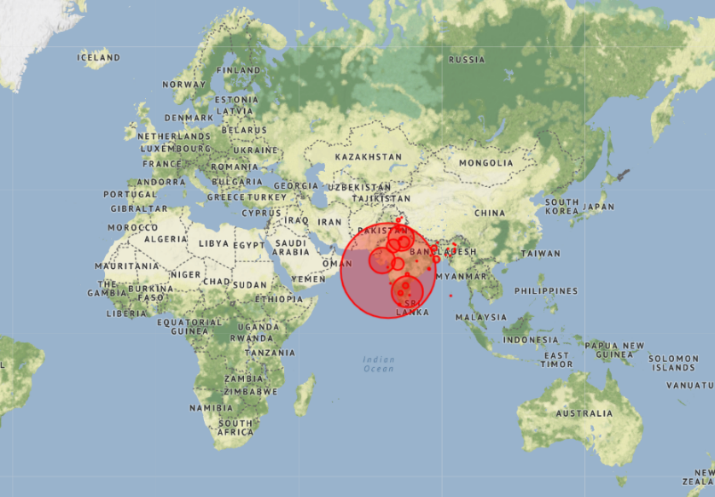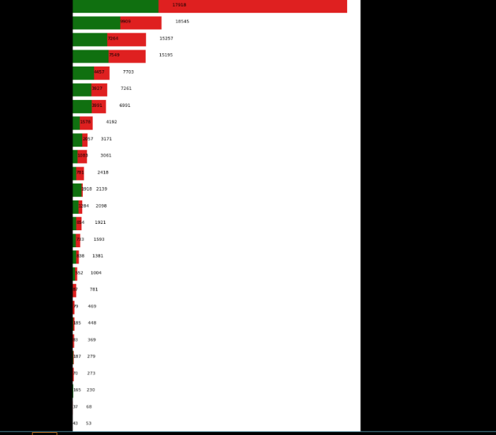 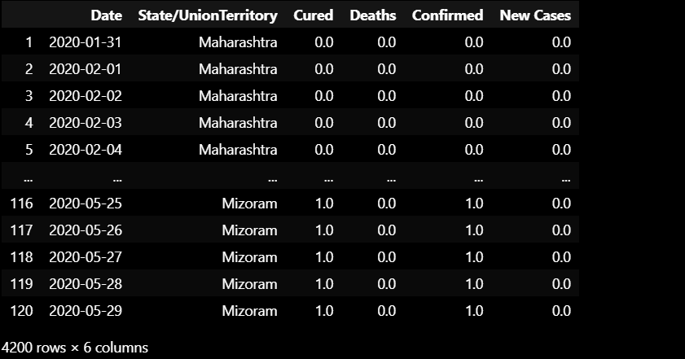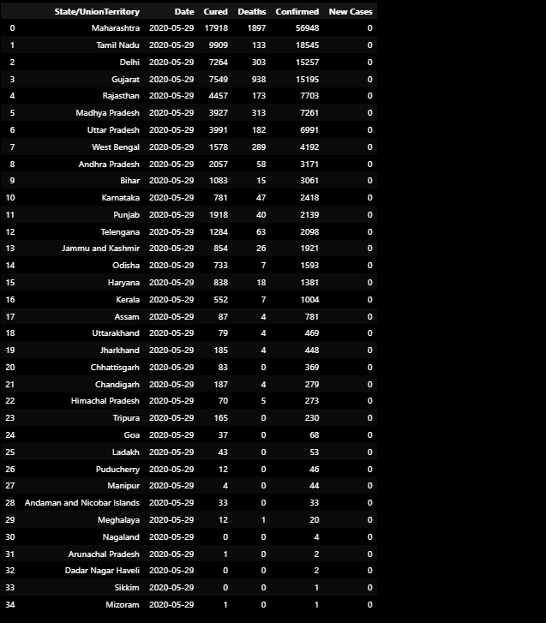

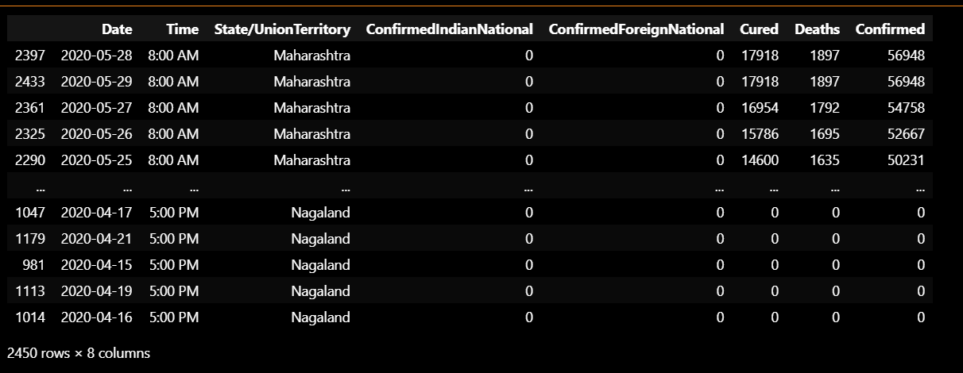

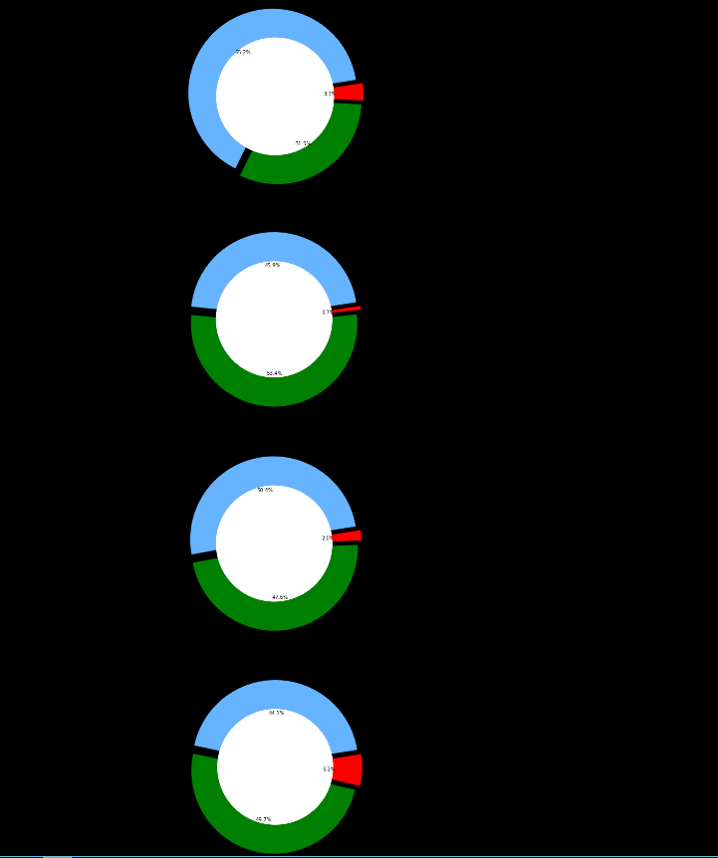

# Feature selection :

Feature selection is an essential step in COVID-19 vaccine analysis, as it helps identify the most relevant variables (features) that contribute to understanding vaccine efficacy, safety, and other important factors. Here are some key considerations and techniques for feature selection in COVID-19 vaccine analysis:

* **Domain Knowledge**: Start by consulting experts in the field, epidemiologists, and immunologists who can guide you in selecting relevant features. Understanding the biology of the virus, the immune response, and vaccine mechanisms is crucial.
* **Data Exploration**: Perform exploratory data analysis (EDA) to gain insights into your dataset. Visualizations, summary statistics, and correlation analysis can help identify initial candidate features.
* **Wrapper Methods**: Employ machine learning algorithms to evaluate the importance of features. Techniques like recursive feature elimination (RFE) and forward/backward selection can help select the best subset of features based on model performance.
* **Filter Methods**: Use statistical methods to filter out irrelevant features. Common techniques include chi-squared tests, mutual information, correlation analysis, and ANOVA. Features with low statistical significance can be removed
* **Embedded Methods**: Some machine learning algorithms (e.g., decision trees, random forests) provide feature importance scores as part of their output. You can use these scores to select the most important features.
* **Dimensionality Reduction**: Principal Component Analysis (PCA) and t-distributed Stochastic Neighbor Embedding (t-SNE) are dimensionality reduction techniques that can help visualize data and select relevant features.
* **Feature Engineering**: Create new features based on domain knowledge or by transforming existing ones. Feature engineering can help capture important relationships in the data..
* **Cross-Validation**: Use cross-validation techniques to assess the impact of feature selection on model performance. Ensure that your model generalizes well to unseen data.
* **Regularization**: If you're using linear models, regularization techniques like L1 (Lasso) and L2 (Ridge) regularization can automatically perform feature selection by penalizing the importance of less relevant features.
* **Expert Validation**: Finally, consult with subject-matter experts to validate the selected features. They can confirm whether the chosen features align with known biological mechanisms and clinical significance.

# Model Selection:

Model selection in COVID-19 vaccine analysis involves choosing an appropriate statistical or machine learning model to analyze and make predictions based on the available data. The choice of the model depends on the specific research questions, data characteristics, and goals of the analysis. Here are some considerations and steps for model selection in COVID-19 vaccine analysis: (e.g., deep learning models).

# Define the Research Objectives: Clearly articulate the research objectives and questions you want to address with the vaccine analysis. Understanding your goals is crucial in selecting an appropriate model.

# 6.Model Training :

Training a machine learning model for COVID-19 vaccine analysis involves using historical data to develop a predictive model that can help analyze vaccine effectiveness, safety, or other related aspects. Here's a simplified overview of the process:

Data Collection: Gather relevant datasets containing information about COVID-19 vaccine outcomes, patient demographics, vaccine types, adverse events, and other pertinent variables. These datasets may come from clinical trials, real-world studies, healthcare records, or other sources.

Data Preprocessing: Clean and prepare the data for analysis. This includes handling missing values, encoding categorical variables, scaling numerical features, and splitting the data into training and testing sets.

# Evaluation Metrics:

In COVID-19 vaccine analysis, several evaluation metrics are used to assess the performance of vaccines and understand their effectiveness in preventing COVID-19 infections and mitigating the impact of the disease. Here are some common evaluation metrics:

Vaccine Efficacy (VE): Vaccine efficacy is a key metric used to measure how well a vaccine prevents COVID-19 in a controlled clinical trial setting. It is calculated by comparing the incidence of COVID-19 cases in vaccinated individuals to the incidence in unvaccinated individuals over a specific period. The formula for VE is:

VE = (Attack rate in unvaccinated group - Attack rate in vaccinated group) / Attack rate in unvaccinated grou

VE is often expressed as a percentage.

Vaccine Effectiveness (VEff): Vaccine effectiveness is similar to vaccine efficacy but is measured in real-world settings rather than controlled trials. It assesses how well the vaccine works in preventing COVID-19 under practical conditions, accounting for factors like population differences, behavior, and variants.

**Feature Engineering**

Feature engineering is a critical step in COVID-19 vaccine analysis, as it involves selecting, transforming, and creating relevant features (variables) from the available data to improve the accuracy and effectiveness of machine learning models or statistical analyses. In the context of COVID-19 vaccine analysis, here are some feature engineering ideas::

**1.Demographic Features:**

* Age groups: Grouping individuals into age categories to analyze vaccine effectiveness across different age demographics.
* Gender: Examining vaccine responses and side effects based on gender.
* Ethnicity or race: Investigating vaccine outcomes among different ethnic or racial groups.

**2. Geographic Features:**

* Location: Incorporating geographic data to analyze vaccine distribution and coverage by region or country.
* Population density: Considering population density as a factor influencing vaccine distribution and infection rates.

**3** **Temporal Features:**

* Date-related features: Extracting day of the week, month, or season to analyze vaccination trends over time.
* Vaccination rate: Calculating the daily or weekly vaccination rate to understand the rate of vaccine administration.

**4** **Virus Variants:**

Identifying the presence of specific COVID-19 variants in the dataset, which can help analyze vaccine efficacy against different variants.

**5** **Healthcare Access:**

* Healthcare infrastructure: Including features related to the availability of healthcare resources, such as hospitals and clinics.
* Accessibility to vaccination sites: Analyzing the proximity of individuals to vaccination centers.

**6. Prior Health Conditions:**

Comorbidities: Creating binary variables to indicate the presence or absence of specific underlying health conditions in individuals, which can affect vaccine outcomes.

**7.Vaccination History:**

Number of vaccine doses: Calculating the number of vaccine doses administered to each individual.

Time since vaccination: Measuring the time elapsed since an individual received their last vaccine dose

.

**8.Adverse Events:**

If you have spatial data, create features that capture spatial relationships, such as distance to

pollution sources, land use types, or geographical clusters.

**9.** **Behavioral Features:**

* Social distancing measures: Incorporating data on the stringency of public health measures in different regions.
* Mask usage: Analyzing mask-wearing behavior and its impact on vaccine effectiveness.

**10.** **Vaccine Type:**:

Categorizing individuals based on the type of COVID-19 vaccine received (e.g., Pfizer, Moderna, Johnson & Johnson) to assess vaccine-specific outcomes..

**11.** **Vaccine Coverage:**

Percentage of the population vaccinated in a given area or time period, which can be a valuable predictor of COVID-19 transmission rates.

## 

## Phase 1 Deliverables:

**1.Data Collection and Cleaning**

Gathering and preprocessing relevant datasets, which may include vaccine trial data, epidemiological data, adverse event reports, and vaccination coverage statistics.

**2.Statistical Analysis**:

Detailed statistical analyses to assess vaccine efficacy, safety, and performance. This may involve hypothesis testing, regression analysis, or survival analysis, depending on the research questions.

**3.Vaccine Efficacy and Safety Reports**:

Reports that provide insights into the effectiveness of the vaccine in preventing COVID-19 infections, reducing severe cases, and assessing its safety profile. These reports often include tables, graphs, and statistical results.

## Next Steps

The analysis of COVID-19 vaccines is an ongoing and multifaceted process. Here are some next steps and considerations in COVID-19 vaccine analysis:

* + **Real-world Effectiveness Studies:** Continue conducting real-world effectiveness studies to assess how well vaccines are performing in the general population. This includes monitoring infection rates, hospitalizations, and severe cases among vaccinated
  + **Safety Monitoring:** Maintain rigorous safety monitoring systems to detect and investigate any adverse events following vaccination. This includes monitoring for rare or unexpected side effects.
  + **Long-Term Effects:** Assess the long-term effects of COVID-19 vaccines, including their duration of protection and potential need for booster shots..

## Additional Considerations

COVID-19 vaccine analysis is a complex process that involves multiple considerations to ensure the safety and efficacy of vaccines. Here are some additional key considerations in COVID-19 vaccine analysis:

1. **Variants of Concern**: Analyzing how well vaccines perform against emerging variants of the virus is crucial. Some variants may impact vaccine effectiveness, making ongoing monitoring and adaptation of vaccines important..
2. **Vaccine Hesitancy**: Analyzing public attitudes and behaviors related to COVID-19 vaccination is important to address vaccine hesitancy and tailor public health messaging..
3. **Distribution and Supply Chain Analysis** Evaluating the distribution and supply chain processes to ensure vaccines are reaching their intended recipients efficiently..

**CONCLUSION:**

In Phase 1   
The conclusion of a COVID-19 vaccine analysis provides a concise summary of key findings and their implications for vaccine efficacy, safety, and recommendations.